**Airline backend System**

**Objective:**

We need to build a backend System that can support different features for an airline company. Our end user is going to be someone who wants to book flights and query about flights so we need a robust system to actually help them give the best experience possible. This doc is solely going to focus on the backend part of the system. We want to prepare the whole backend keeping the fact in mind that the code base should be as maintainable as possible.

**Requirements:**

* A user should be able to search for flights from one place to another.

- Users should be able to mention the source and destination details.

- Users should be able to select the date of the journey.

- [v2] users should be able to search for return flights and multi-city flights.

- Users should be able to select the class of the flights. [Non mandatory]

- users should be able to select the number of seats they want to book [NM].

- Now based on the above data, we will list down the flights.

- we should show our users the best available flights at the top based on time period

of flights and then based on the prices.

- we need to support pagination so that we can list chunk of flights at one point of

Time.

- we should support filters of flights based on the Price, departure time, Duration airline

Stops.

- [v2] we can add support for more filters.

- A user should be able to book a flight considering that user is registered on the platform.

- Users should be able to cancel a booking, and then based on some criteria we can

initiate a refund for them.

- users should be able to request and book excess luggage for every flight.

- For making a booking, the user has to make a payment [dummy].

- Tracking flight prices should be possible the user should be notified about ant prices drops of

any delays.

- users should be able to list their previous and upcoming flights.

- Users should be able to download boarding passes if they have done online check-in.

- online check in machanism should be supported.

- Notification via email for completing online check-in before 3 hours of departure.

- Notification to users about ant flights delay.

- users should be able to review the flight journey if and only if they have booked a flight.

- reviews mechanism should involve star rating along with a comment.

- while listing any flights we should also display the review of the flights.

- Users should be able to authenticate to our system using email and password.

- [v2] support ticketing, where user can raise their queriess.

- Listing FAQ which will be static data

- [v2] Prepare seal selection

- coupons for discounts and offers.

- While making a booking a person can reserve more than one seat with one login-id.

**Non-Functional Requirements:**

* We can expect that we are going to have more flight searches than flight booking.
* The System needs to be accurate in terms of bookings.
* Expect that we will be having approx 1,00,000 total users, 5,00,000 Bookings might come up in one quarter.
* So in one day we can expect 5000 bookings.
* System should be capable of scaling up to at least 3x the current estimated traffic.
* The system should handle real time updates to flight prices, before the user makes the final bookings.
* Concurrency should be handled, using RDBMS should be the good solution.

**Capacity Estimation:**

* Storage estimates -
  + For the upcoming 5 years, 80,00,000 bookings, 2,00,000 Users, Considering all the users records and bookings records take 10 MB of data. The overall 10 TB of memory should be fine for our initial pilot run.

- Traffic estimates -

- If we consider 30:1 as the search booking ratio, then at max we expect 150000

search queries a day. 2 query/sec.

**1.Search and Flight Services** 👍 [City Database]

* Create Flights
* Delete Flights
* Update Flights
* Search for Flights
  + Based on multiple filtration criteria we can search for flights
  + Pagination

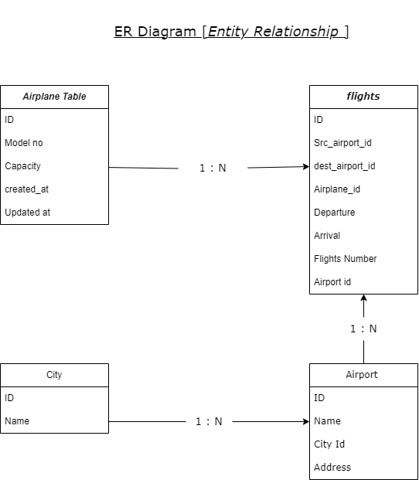

2.